IO2 Networking: Developing Strategic Learning Networks in the Region

The methodology of IO2 focuses on how the stakeholders can be managed effectively so that the strategic goals defined in IO1 of the educational institutions will be realised.

The relevant stakeholder shall be identified using analysis techniques to organise participation, creating ideas for strategic interventions, above all, for problem formulation and solution search. Stakeholders are individuals, groups or organisations that must be considered by the change-agent.
The following steps should be followed during the exercise to develop such regional learning networks.
STEP 1 Securing framework conditions
STEP 2 Inventory of regional knowledge
STEP 3 Knowledge offer of the regional knowledge institutes
STEP 4 Deploy content of the knowledge agenda
STEP 5 Make a deal with the identified stakeholders
The steps are supported with two sub actions as (1) determining the models for network structure and (2) the development of a methodology for building a triple helix learning network structure.
Models for Network Structure
Depending on which model you use, we recommend on the steps.
In this first step, the growth model is used. The growth model¹ shows how to work systematically towards a sustainable cooperation in the region; from ad hoc co-operation to sustainable cooperation within shared projects and tasks to achieve the goal, which is to work within one organization and to grow together. The growth model shows how and what steps should be taken to achieve this goal.
The growth model works with four platforms. Each platform requires a different way of collaboration and network structure, representing an increasing growth in co-operation and network structure.

¹source: Digitaal Handboek Regionale Verankering, HAN | Kenniscentrum kwaliteit van leren
Aimée Hoeve, Femke Timmermans, Loek Nieuwenhuis, Derk-Jan Nijman m.m.v. Woody Maijers, Gonneke Leereveld

Figure1 The Growth Model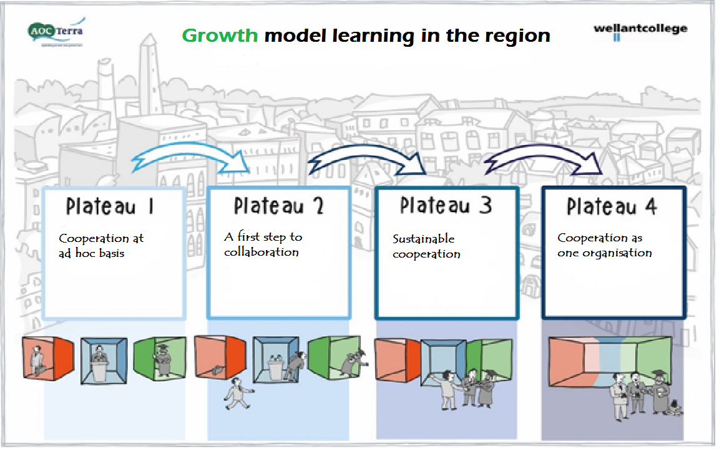
In order to identify on which platform your institution is situated; the following steps or actions are recommended:
STEP 1 Determine the status and identify prospects; the three spheres model can be used.
STEP 2 Think about the position of the other organisations (government and research) and get into conversation with them.
STEP 3 Identify potential bottlenecks.
Development of a Methodology for Building a Triple Helix Learning Network Structure
Another way of developing a strategic learning network is facilitated by the ‘Partnership Map.
When you use this ‘Fill Map Partnerships.’, follow these steps.
The instrument “Fill Map Partnership”² helps to discuss the initial phase of a process with different stakeholders, where cooperation works towards (what are the goals, the expectations) and what steps need to be put to get there and which method fits best here. These steps are arranged in columns VALUES, RELATIONS, ACT, CONDITIONS and ACTIONS. Through an exercise, the steps to build a structure of cooperation in the triple helix, can be put.
Required actions
By completing the map separately first (e.g. by individual members of teams, a team or a partner) and then comparing the results, it becomes clear whether the expectations of all partners are the same. Thereby it becomes clear immediately what it takes to get there together.

²source: Digitaal Handboek Regionale Verankering, HAN | Kenniscentrum kwaliteit van leren
Aimée Hoeve, Femke Timmermans, Loek Nieuwenhuis, Derk-Jan Nijman m.m.v. Woody Maijers, Gonneke Leereveld

Methodology

STEP 1 The partners get a request to fill in the Fill Map Partnership.
STEP 2 Collect the maps
STEP 3 Analysis takes place by all partners
STEP 4 A shared map is filled through discussion with all partners

How to fill in the map?
The partnership map is filled in from the right to the left. Try to focus on each step, fill in the map completely. There are no wrong answers.
Questions addressed
- What values do we ask when we talk about successful cooperation?
- If the values are determined: how do you work together in terms of the interrelationships?
- (…) and the requirements for acting and skills needed of the partner?
- What conditions are set to perform the required actions and to maintain relations?
- The whole is finished with the declaration of the individual actions, group actions and actions of others.
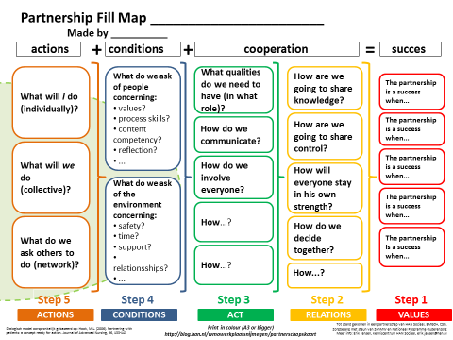
Figure2 Fill Map Partnership

