Annex to IO3 Capacity Building

In the current annex, the experiences of the Biological Post-Secondary VET School are summarized giving an example for the other educational intuitions how a grid for repositions can be developed based on the proposed methodology.
SWEDEN
Educational Institution | Biological Post-Secondary VET School, hereinafter: BYS
Description of institution | The local project of PV+ within Region Västra Götaland (Västra Götalandsregionen) is allocated at the Department of Natural Resources (Naturbruksförvaltningen) involving the Biologiska Yrkeshögskolan (Biological Post-Secondary VET School, hereinafter: BYS). It is an agricultural education center at the higher vocational education and training level (EQF level 5-6). BYS is centrally located in Skaraborg. The programs at Post-Secondary VET School are always designed on a skills-need basis and in collaboration with trade and industry. The students’ knowledge development during their studies can be integrated with the needs and demands of the field.
Methodology | In Sweden both interviews and group exercises have been performed with the target group: teaching personal and management of BYS.
Results | The aim of the action is to determine the available and desired services for the institution based on the developing the service portfolio. And a flow chart is established explaining the work flow and the structure of the network.  The above exercise together with the research of the University of Skövde detailed under IO 2 made the following challenges visible.  A coordinator is needed to facilitate the students’ projects to make it possible to divide the projects among work placement periods and even among students. This coordinator shall be a part of the school, preferably work as program coordinator to match the wishes of the branch of trade, the interest of the students and “tailor-made” the course aims.  How to bridge the gap?  In June 2017, BYS recruited a program coordinator whom has a special focus on the current project aims. The program coordinator gets help in case of organization matters (meetings with municipalities, companies, stakeholders) from the Competence Centre at the Department of Natural Resources where an additional staff was recruited in June 2017 working part-time (50%) with internationalization.  As part of the capacity building, University of Skövde interview the management of BYS based on the developed 7S model constructed by McKinsey¹. This instrument is to support boards of institutions in determining their own administrative agenda in view of the internal capacity needed to realize the current regional positioning. However, the exercise with the 7S model does not show a useful patter, i.e. no priority areas are established.  Establishing the flow chart, questions will be gathered from the steering and leading committees via the steering and leading committees. The questions will be checked. If the question fits, it will be broken down to student projects in the educational programmes as part of work place based learning. It requires the application of the courses’ aims and the curricula to make the student projects able to deliver solutions for the questions posed by the business. The proposed solutions will be presented at the steering and leading committees catalyzing new questions. The questions will be shaped as part of multi-funding base projects delivered by BYS.  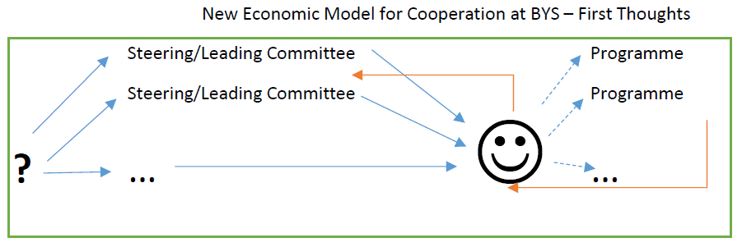
Important conclusions | The above model integrates the branches of trade with the education. Moreover, the competence and the contributions of the University of Skövde is also required to break down the questions of the branches of trade into student projects in the educational programmes. Concerning multi-funding base projects, the Competence Centre at the Department of Natural Resources is involved as a public body.  As a result, a structured cooperation is supposed to be developed. Implementing the above model, a qualitative change is expected in the education. The branch of trade will follow the students inspiring them with their questions. If a student has a certain interest, there will be an opportunity to merge several work placement assignments that may eventually lead to a well-structured degree project. Public bodies are invited to cooperate via multi-funding base projects.
Link with the pilot case | The pilot case is delivered inside the above suggested new mechanism for cooperation in the regional learning network.

¹source: Digitaal Handboek Regionale Verankering, HAN | Kenniscentrum kwaliteit van leren
Aimée Hoeve, Femke Timmermans, Loek Nieuwenhuis, Derk-Jan Nijman m.m.v. Woody Maijers, Gonneke Leereveld

